JPO 152 Assignment 5
Potential Energy and Energy Conservation
Due date: 19th April 2013
Surname:
Student No:
Field Of Study:
Group:
Total | /20

I am aware of the University of Pretoria’s plagiarism clause and steps that may be taken against me, should I be found guilty. This work is my original effort.

Signature: __________________
Question 1 [10]
- A ball is thrown upwards and the effects of air resistance cannot be ignored. When it reaches the same position that it was launched from the speed at which you catch it is less than the speed at which you launched it. Explain why using energy concepts(3)
The ball experiences a resistance force due to air resistance. This resistance force is a non-conservative force which means that the principle of conservation of mechanical energy is no longer applicable in this situation and there must be some other energy change present resulting in:
$∆E_{mech}<0⇒E_{k,f}<E_{k,i}$ since $∆E_{P}=0$ (same height)
- Can friction ever do positive work? Explain (3)
No. Only kinetic friction can do work since in only this case will the box move. $W=Fd\cos{θ}$ and for friction the angle between F and d is 180° which means that $W=-f_{K}d<0$
- A physics teacher sets up a demonstration of the principal of conservation of mechanical energy by suspending a bowling ball from the ceiling by using a rope to create a giant pendulum. He would back up to one side of the stage and raise the ball to his nose and releases the ball. The ball travels in an arc across the stage and then returns along the same path to stop at the exact same position he released the ball in front of the stationary teacher. After the lesson while the teacher is distracted a student attempts to replicate the result. The teacher turns around just in time to see the student push the ball away from his nose. Tell the rest of the story and explain why this result happened (4)
By pushing the ball away the student introduces an initial kinetic energy to the ball thus the mechanical energy of the ball is higher.
Mechanical energy is conserved in this isolated system since only conservative forces act on the ball during its flight. Hence when the ball returns and reaches the same position it still has excess kinetic energy and will travel to a greater maximum height, thus striking the student in the face.

Question 2 [10]
Genetic manipulation and modification have enabled a group of daring scientists to recreate dinosaurs and wish to create a theme park/zoo where the exhibits are living dinosaurs. You have been commissioned by the park as an independent “expert” to sign off on the safety of the park. Not unexpectedly the dinosaurs escaped and now all the scientists are dead. You managed to escape the slaughter by bravely hiding away are left to fend for yourself. Currently you are on top of a storage shed looking at the exit to the park. Unfortunately a velociraptor is between you and freedom. After doing a quick inspection of the shed you manage to assemble a canon that hurls rocks based on a spring system and strap it to the roof as shown below:
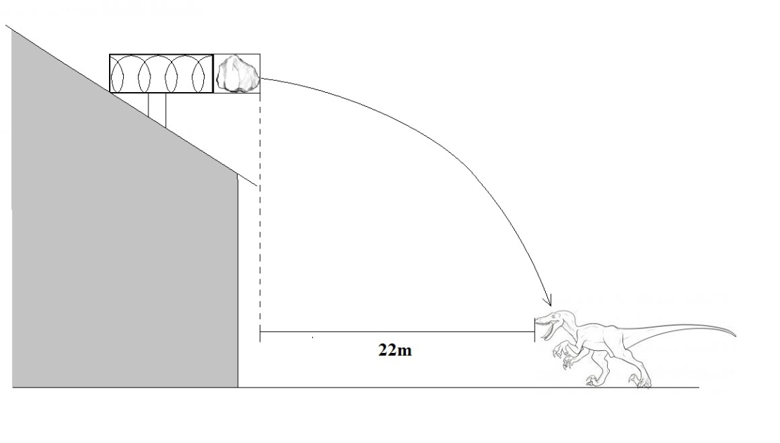
On the first shot you compress the spring 20 cm but the rock falls 30cm short of the velociraptor’s head. Taking a second rock of equal mass, how far should you compress the spring in order to hit the beast on its head?

By conservation of mechanical energy in the cannon:
$\frac{1}{2}kx^{2}=\frac{1}{2}mv^{2}$ (1)
Since after the rock leaves the canon it is a projectile with zero vertical velocity
$h=\frac{1}{2}gt^{2}$ and $v=\frac{d}{t}$ where d is horizontal distance travelled
Hence $v=\frac{d}{\sqrt{\frac{2h}{g}}}⇒v^{2}=\frac{d^{2}g}{2h}$ (2)
Combining (1) and (2) one gets
$$kx^{2}=\frac{d^{2}gm}{2h}$$
$$\frac{x^{2}}{d^{2}}=\frac{gm}{2kh}$$
Since $\frac{gm}{2kh}$ is a constant value then it is the same for both shots and
$${\left(\frac{x^{2}}{d^{2}}\right)}_{1st shot}=\frac{gm}{2kh}={\left(\frac{x^{2}}{d^{2}}\right)}_{2nd shot}$$
$$\frac{{(0.20)}^{2}}{{21.7}^{2}}=\frac{x^{2}}{{22}^{2}}⇒x=20.28cm$$

